**Ideation Phase**

**Define the Problem Statements**

|  |  |
| --- | --- |
| Date | 14 October 2022 |
| Team ID | PNT2022TMID52849 |
| Project Name | Project - Personal Assistance for Seniors Who Are Self-Reliant |
| Maximum Marks | 2 Marks |

**Customer Problem Statement:**

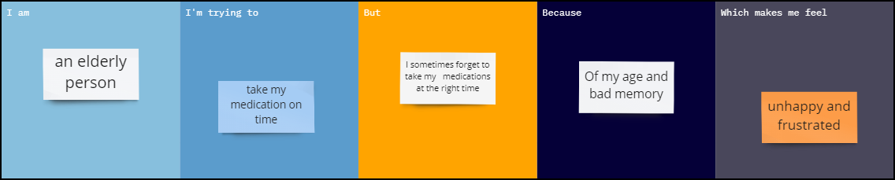

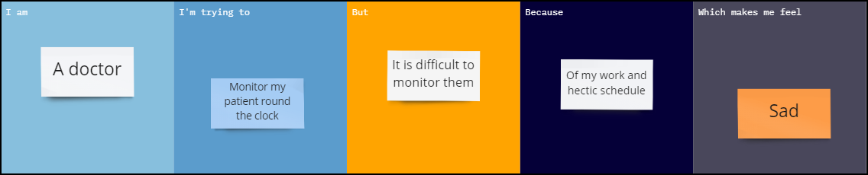

|  |  |  |  |  |  |
| --- | --- | --- | --- | --- | --- |
| **Problem Statement (PS)** | **I am (Customer)** | **I’m trying to** | **But** | **Because** | **Which makes me feel** |
| PS-1 | An elderly person | Take my medication on time | I sometimes forget to take my medications at the right time | Of my age and bad memory | Unhappy and frustrated |
| PS-2 | A doctor | Monitor my patient round the clock | It is difficult to monitor them | Of my work and hectic schedule | Sad |